
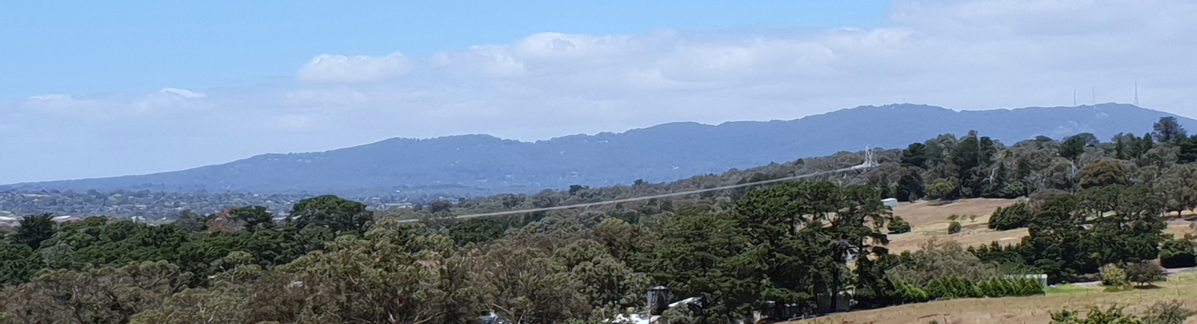

The Journal of the National Seniors Australia Yarra Ranges Branch Inc
Incorporation No. A0048800C Branch No 100132
Yarra Ranges Grapevine
NOVEMBER & DECEMBER 2025

Membership Renewals & Joining Members
There are new Membership Renewal / Joining Application Forms on the last page of this Newsletter. The Branch receives a small annual payment for your Membership.
Branch Meetings 2025

Monday – 10 November

7.00pm for 7.30pm

‘Home Care Packages’

Presenter: Lesley Camerilli

From Silverchain at

Lilydale Lake Community Rm

++++++++++++++++++++++++++++++++++++

Monday – 8 December

6.30pm

‘Chat’n’Chew EOY Picnic’’

At The Lilydale Lake Room

No Branch Meeting

January 2026

****************************

(Speaker ideas please)

If you have a

suggestion for

a ‘Guest Speaker’

please contact

the Secretary or

place in the

‘Suggestion Box’
President’s Report
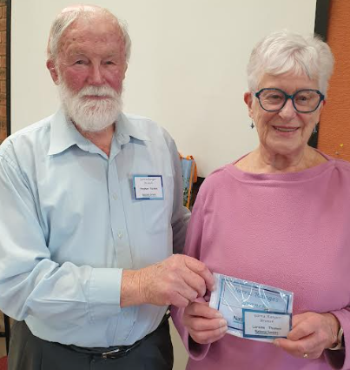
Hi Members,

At the Crown the Dinner Meeting was well attended on Monday night as usual, seems to be an attraction for our members.

Chris has had plenty of activities for members to attend.
Vice President Steve welcomes Laraine to YRNSA

I hope Chris was able to recruit some more volunteers for the lost children's department at the Lilydale show this year.

I had my name down for both days but we are going to see our grandchildren before Christmas.
Next meeting at The Lilydale Lake Community Room on Monday 10th November.

It is daylight saving now so the Branch Meeting will be 7.00pm for a 7.30pm start. Please note the change of time.

Happy reading. Trevor President
COMMUNITY INFORMATION NOTICE:
JP facilities are available at the Croydon & Lilydale Police Station on the following days and times –
Croydon Tuesdays 10.00am to 1.00pm
Lilydale Thursdays 10.00am to 1.00pm



Yarra Ranges NSA Branch Committee

President

Trevor - 9735 1104

Vice President & Welfare Officer

Steve - 0427 394 642

Secretary

Newsletter Editor

Lyn F – 0459 155 527

Email: yarrarangesnsa@gmail.com

Treasurer

Lyn J - 0418 598 521

Activities Coordinator

Chris - 0419 528 446

Email: chrishill3@bigpond.com.au

Guest Speaker Coordinator

Vacant

Web Administrator

Patrick

0413 726 726

Committee Member

Elaine - 0427 394 642

Kathy - 0438 257807


Welfare Officer Please contact our WO if you know of anyone who is unwell, having an operation, in need of help or has passed away within the family.
Vice President & Welfare Officer Steve on 0427 394 642
******************************************************************************************************

Congratulations to!
17 Nov - Diane 6 Dec - Gail
20 Nov - Lois 11 Dec -Helen
14 Dec -Lorraine Sc
We would like to celebrate your day!
Don’t forget to email / phone your birthday & month to Lyn at yarrarangesnsa@gmail.com

DIARY DATES

‘WELCOME’ to our BRANCH MEETING DATES - 2nd Monday of the Month
Meet at: ‘Lilydale Lake Community Room’, Lilydale Lake Rd, off 435A Swansea Rd Lilydale

Monday 10 November @ 7.00pm for 7.30pm


‘Home Care Packs – Silverchain’

Presenter: Leslie Camerilli

Monday 8 December @ 6.30pm onwards

‘Chat’n’Chew EOY Picnic’

No January Branch Meeting 2026

Please email your ideas for Guest Speakers or Activities to – yarrarangesnsa@gmail.com or pop in the ‘Suggestion Box’
*******************************************************************

COMMITTEE MEETINGS - 1ST Monday of Month

@ Chris’ place

Monday 3 November Monday 1 December

***************************************************************************
* NOTE FROM CHRIS *

Everyone needs to please text or email Chris - 0419 528 446

Email: chrishill3@bigpond.com.au
with any changes you want to make after they have put your name down for an ‘Outing & About’ / ‘Dining Out’ / ‘Morning Melodies’.

Also, if you put their name down for an ‘Outing & About’ / ‘Dining Out’ / ‘Morning Melodies’ please make sure you put it in your diary, so you don’t overlook or forget what you have made a commitment that date.



‘OUT & ABOUT’ – BLUE ‘DINING OUT’ – PINK
‘MORNING MELODIES’ - GOLD
Activities

Please Contact Chris ‘Activities Coordinator’ to Book and to cancel in time
Please Note: All payments in an envelope with name, amount of payment and Activity name.
This will be a great help. Thank you, Chris

‘Out & About’ – Blue ‘Dine Outs’ – Pink ‘Morning Melodies’ – Gold

MORNING MELODIES @ The International Hotel Maroondah Highway Lilydale
Please note: Order lunch before show at 11.00am. Lunch 12.00noon

Wednesday 5 Nov @ 11.00am ‘Song & Dance Man’ – Brendan Scott
Friday 14 Nov @ 6.30pm ‘Trivia Night for Caladenia’ at Mooroolbark Bowling Club Cost: $15
Saturday 15 Nov @ 9.00 – 7.00pm ‘Lost Children Area Roster’ at Lilydale & Yarra Valley Ag Show
Sunday 16 Nov @ 9.00am – 5.00pm ‘Lost Children Area Roster’ at Lilydale & Yarra Valley Ag Show
Monday 17 Nov @ 8.00am (L’dale) ‘Bendigo Day Out by Train’ Exploring Bendigo
Wednesday 3 Dec @ 11.00am ‘Christmas Show’ – The Baby Boomers
Sunday 7 Dec @ 9.00am – 4.00pm ‘Lilydale & Melba Festival & Street Fair’ Main St Service Rd Lilydale
Roster needed for Awareness Tent 9am – 2.30pm
Sunday 7 Dec @ 5.30pm ‘Christmas Dinner’ Sanctuary House 326 Badgers Creek Road
Badgers Creek Cost: $60 Christmas Hamper Raffle Draw
Thursday 18 Dec @ 12.30pm ‘Angie’s Dumplings’ in Reading Cinema Complex Chirnside Park
Thursday 15 Jan @ 6.00pm ‘Fish’n’Chips at Warrandyte’ at Stiggants Reserve BYO chair, drinks
Tuesday 27 Jan @ 12.30pm TBC
Wednesday 11 Feb @ 12.30pm TBC
Sunday 1 March @ 12.00pm ‘Chris’ Café’ @ 3 Mangans Road Lilydale - Providing Nibbles, Roast,
Salads, Desserts, Tea / Coffee $25

‘SATURDAY WALKS’ - Contact Chris ‘Activities Coordinator’ for details
Please Note – Walks start during EST at 9.00am (Daylight Saving). Over 30deg 8.30am
These 2 photos are from the same walks – do you know where? Answers in next ‘Grapevine’ Photos 1 & 2 in ‘September & October’ Grapevine’ – Lilydale Lake Walk
Sat 1 Nov Mooroolbark Comm Centre
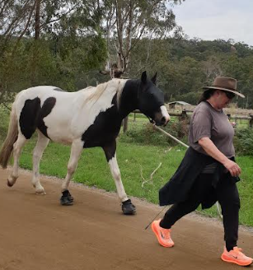
Sat 8 Nov Millgrove to Warburton for Lunch
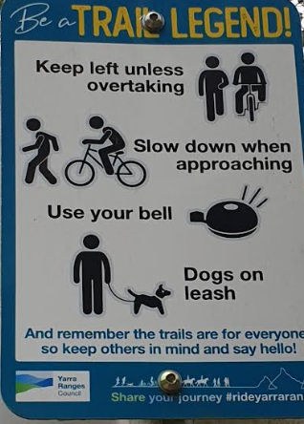
Sat 15 Nov Lilydale Lake
Sat 22 Nov Wandin to Seville
Sat 29 Nov Norton Road Croydon
Sat 6 Dec Mullum Mullum Burnt Bridge
Sat 13 Dec Barngeong Res Croydon Nth
Sat 20 Dec Lilydale to Mt Evelyn
Sat 27 Dec Lilydale Lake
Sat 3 Jan Lilydale Lake
Sat 10 Jan Dorset Reserve Croydon
Why is the horse wearing shoes?

Note: If there is an all day ‘Out & About’ organised, we won’t be walking

OTHER NEWSY BITS!



Contributions to our Newsletter


Have you been travelling?

Have you attended a good show?

Have you read a good book?

Is there something you have experienced, that you would like to share with the members of the Branch?

A story? One-liners? Photos from outings?

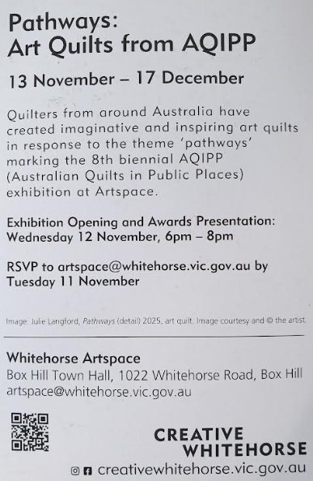
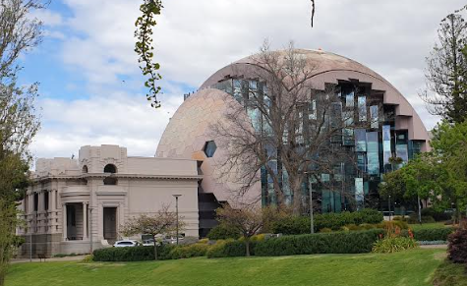

*************************************************************************************************************************

******************************************************

The ‘Archibald’ @ Geelong

Travelling down on the comfortable country train to Geelong with a short walk across parkland to the Art Gallery and magnificent Library building.

Lunch at the Library Gallery Café before going to the Archibald was a good idea.

Chris had organized our tickets and we wandered through the various gallery areas critiquing the various Archibald entries.


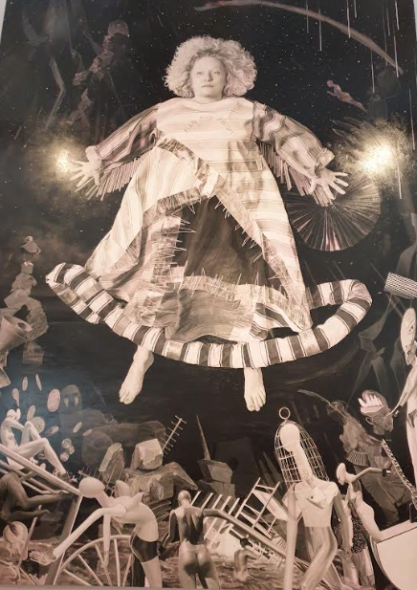
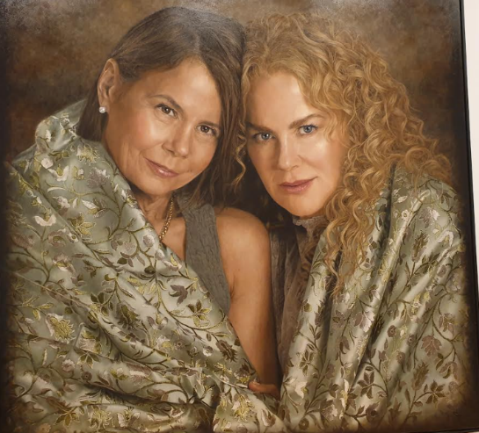

We formed our various opinions and will let you work out which one was the winner of the ‘Archibald’ and which was the choice of the ‘Packing Room’ from the following paintings.

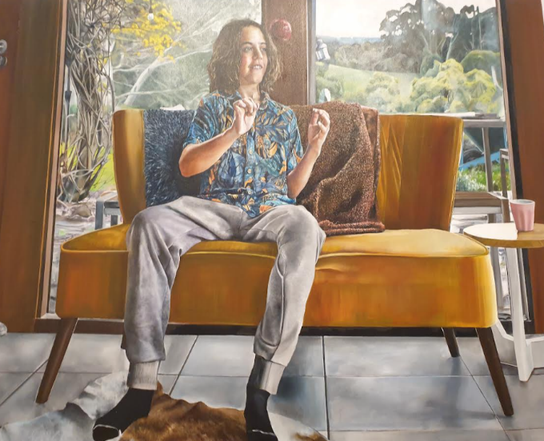

*************************************************************************************************************************


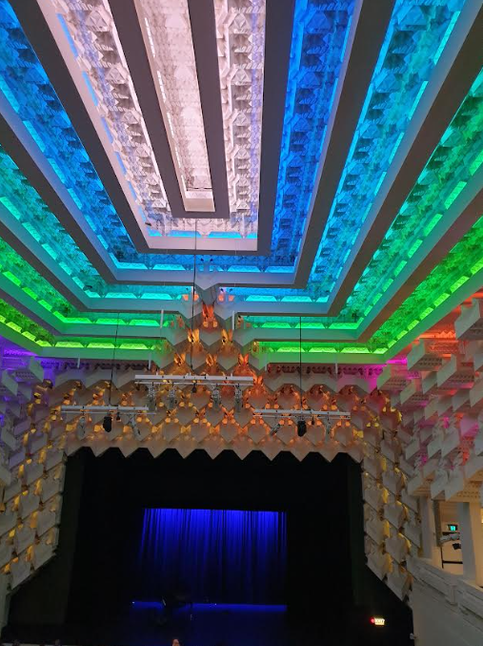
The Capitol Theatre in Melbourne is an iconic, restored Art Deco cinema and cultural venue owned by RMIT University, located on Swanston Street.
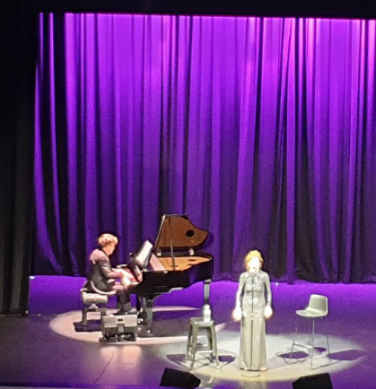

Originally opened in 1924, it is famous for its unique "crystalline cave" interior designed by Walter Burley and Marion Mahony Griffin, with a dazzling ceiling that was once linked to orchestral music. After a major refurbishment, it reopened in 2019 to function as an educational space by day and a cultural venue for film, performance, and other events by night.

So, it was a great opportunity to be able to attend the Capital during a ‘Seniors Week’ performance of Judy Garland songs.
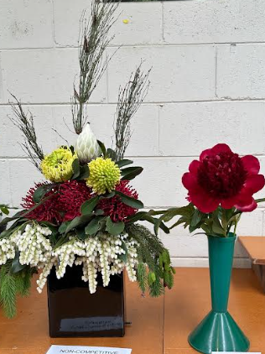
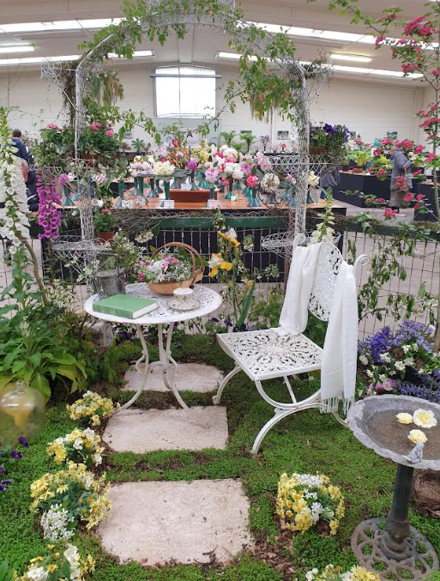
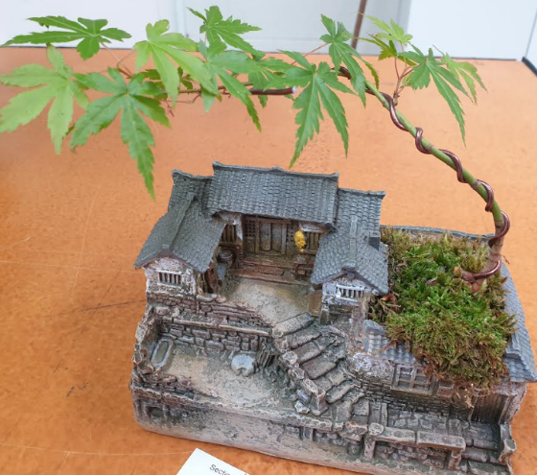
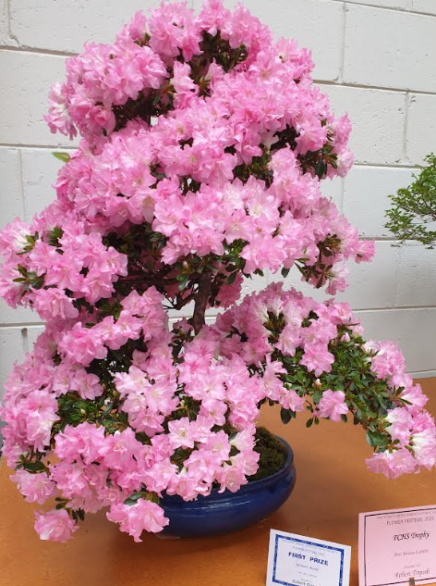

The Ferny Creek Horticultural Society Inc

“Flower Festival’

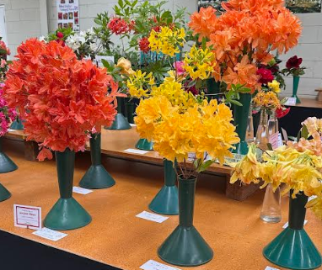
What a great way to spend a Saturday afternoon admiring the talents of our gardening enthusiasts of the FCHS.

The top left was conceived and organized by one of the women who was very proud of her achievements.

The top pink Azaelia is actually a spectacular Bonsai!


The Lighter Side of Life!

A man walks into a restaurant with a full-grown ostrich behind him. The waitress asks for their order.
The man says, “I’ll have a hamburger, fries, and a coke.”
He turns to the ostrich and asks, “What about you?” “I’ll have the same,” says the ostrich.
A few minutes later, the waitress brings the food and says, “That’ll be $9.40.”
The man reaches into his pocket and pulls out the exact change. No counting. No wallet. Just the right amount.
The next day, the same thing happens. Same order. Same ostrich. Same exact change.
This goes on for days.
Then one Friday night, the man says, “Today I’ll have a steak, baked potato, and a salad.”
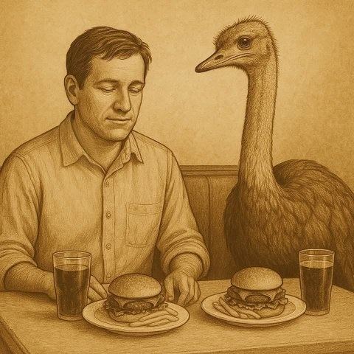
“Same,” says the ostrich.
The waitress brings the food. “That’ll be $32.62.”
Once again, the man reaches into his pocket and pulls out the exact amount.
At this point, the waitress can’t hold back, “Sir… how do you always have the exact amount of money no matter what you order?”
The man smiles.
“Well, a few years ago, I found an old lamp in the attic. I rubbed it, and a Genie appeared. He gave me two wishes. For the first one, I asked that anytime I needed to pay for something, I’d just reach into my pocket and find the exact amount.”
“Wow,” says the waitress, “That’s smart. You’ll never run out of money.”
“Exactly,” says the man, “Whether it’s a cup of coffee or a new car, I never need to check. It’s always just there.”
She looks at the ostrich and asks, “And the bird?” The man sighs and says, “For my second wish… I asked for a tall chick with long legs who’d follow me around and agree with everything I say.”
****************************************************************************
A Chinese doctor moved to the U.S., but couldn’t land a job at a hospital. So, he decided to open his own little clinic and hung a sign outside that read:
“Get treatment for $20 — If not cured, get $100 back!”
One day, an American lawyer saw the sign and thought, "Easy money!" So, he walked in.

Lawyer: “Doc, I’ve lost my sense of taste.”
Doctor: “Nurse, bring medicine from box No. 22. Put three drops in the patient’s mouth.”
Lawyer: “Ugh! That’s kerosene!”
Doctor: “Congrats, your taste is back! That’ll be $20.”
Annoyed but not giving up, the lawyer returned a few days later.
Lawyer: “I’ve lost my memory. I can’t remember a thing.”
Doctor: “Nurse, bring medicine from box No. 22 and put three drops in his mouth.”
Lawyer: “Hey — that’s kerosene! You gave me this last time!”
Doctor: “Congrats, your memory’s back! That’ll be $20.”
Now fuming, the lawyer came back one last time, determined to win the $100.
Lawyer: “Doc, my eyesight is so bad — I can’t see a thing!”
Doctor: “I’m sorry, I don’t have any medicine for that. Here’s your $100.”
The doctor handed him $20.
Lawyer (squinting): “Hey, wait! This is only $20, not $100!”
Doctor: “Congrats, your eyesight’s restored! That’ll be $20.”
******************************************************************************************************
Two women waited for St. Peter at the Gates of Heaven. The first woman asked the second how she ended up there. The second woman said “It was very dark and cold and I was shivering and it was unbearable. I was so cold I slowly faded from consciousness and died. What about you?”

The first woman said “I was convinced my husband was cheating on me, so I went home early from work to catch him in the act. I burst into the house but he was watching TV. I wasn’t convinced, so I tore through the house like a mad woman, looking in every room and closet and under each bed. I got so worked up I had a massive heart attack and died, so here I am.” The second woman responded “Well I sure as hell wish you would have looked in the freezer. Then we would both still be alive!”

^^^^^^^^^^^^^^^^^^^^^^^^^^^^^^^^^^^^^^^^^^^^^^^^^^^^^^^^^^^^^^^^^^^^^^^^^^^^^^^^^^^^^^^^^^^^^^^^^^^
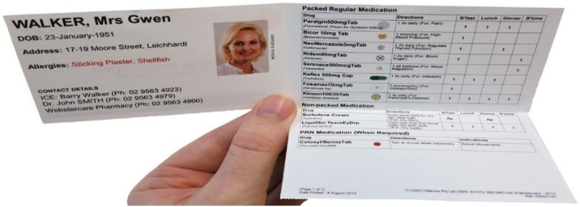
Update your medicines list now – you’ll need it if you go to hospital

A medicine list is a complete list of all your prescriptions, over the counter and complementary medicines.

Now is the time to make sure you have that list up-to-date and easy to find in case you unexpectedly have to go to hospital or visit a doctor or pharmacist who is not familiar with your health status.
*************************************************************************************************************************
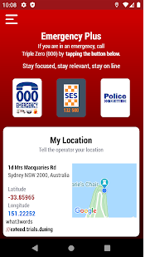
Please ensure you have this app installed on your phone – it could save lives and maybe even your own.

Emergencyplus is an app you can put on your mobile. (It was recommended by a trainer who trained the staff at my school.)

You can choose to load onto an Apple or Android system (2nd choice).

When loaded the right-hand screen will appear.

The OOO Emergency, SES & Police are live buttons that will automatically call that service when pressed.
Also, you will note your ‘location coordinates’ appear so you can pass the information to the service concerned as to where your location is.

************************************************************************************************************************************************************************
MORE STICKERS HAVE ARRIVED!
‘Keep Cash’ Campaign
We have obtained more stickers from Head Office in Brisbane for distribution to local traders and retailers who wish to continue receiving CASH. These are available now.
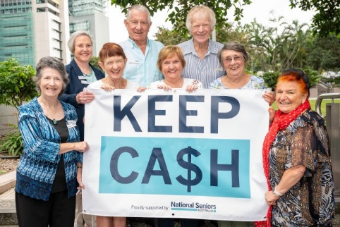

NSA wants to help buck the ‘cashless society’ trend and keep cash circulating. To do this, they need our help to encourage retailers that accept cash to display our new ‘We accept cash’ sticker.
Let’s get our message out there. All we need to do is encourage retailers in our local area to display the ‘We accept cash’ sticker for customers to see.
You could even take a photo of the sticker being displayed and email it to us at policy@nationalseniors.com.au Participating businesses are added to NSA website page and shared on our social media.

****************************************************************************************************************************Some News Items from National Seniors
that you may have missed

11 ways to make older Australians happier

A new NSA report explores 11 paths to happiness among older Australians, based on 2,516 survey comments.
If we asked you to describe something that would maintain or increase your happiness, what would you say?
The NSA Research Team asked participants in this year’s National Seniors Social Survey to do just that.
The result is a new report that explores 11 different ways of thinking about happiness among older Australians.
This work matters because, as an advocacy organisation, the wellbeing of older people is core to our business.

While broadscale structural and societal factors are our usual focus, we also know that individuals’ responses to those factors can vary.
The somewhat elusive concept of “happiness” is a way of drilling into those individual differences.
As our wellbeing includes our mental health, and happiness is an obvious part of that picture, it’s fitting that we launch the affectionately dubbed ‘Happiness Report’ to coincide with Mental Health Month (October).

Eleven faces of happiness
When we asked the happiness question, 2,516 survey respondents aged 50 to 97 gave an answer.
As you can imagine, the 2,516 comments our respondents wrote were extremely diverse. Happiness means different things to different people.
That’s the take home message really – how different we all are – older people cannot be boxed into stereotypes.
But we asked a survey question, so we had to try and make sense of what the 2,516 people said.
We’ve asked a lot of survey questions in the past, and from experience we know the issues that will come up time and again on people’s wish lists.
More money, better health, secure housing, quality aged care, and human company are some of the most common.

Those things were mentioned among the happiness comments too. So, we could have taken those same “issues” approach to analysing the 2,516 comments.
But that seemed a pointless activity, telling us what we already know.
Instead, we thought outside the box and sliced the comment set differently.
We tried to read between the lines to the deeper motivations that prompted people’s answers.
For example, more money is often a pathway to happiness for people who are feeling financially tight. In such cases it’s really about survival.
And quality aged care isn’t just a good thing for its own sake. It can be a pathway to happiness because it enables independence and control.

Thinking about people’s answers this way, we came up with 11 “personas” that seemed to capture what people really wanted, and these form the basis of the report.
The 11 personas go straight to the sources of happiness – the principles and ideals, beliefs and habits, priorities and desires that shape our personalities and drive our lives.

The 11 personas and their typical routes to happiness are:
- Survival Realists. Happiness is having enough money to cover the basics including housing, and where possible a little bit extra.
- Fierce Independents. Happiness is staying independent through great health, wealth, and care, and having control of our life choices.
- Keen Participators. Happiness is the time, money, and ability to pursue our interests, be they travel, hobbies, work, or volunteering.
- Nest Featherers. Happiness is a great home life with a wonderful location, loving partner or solo bliss, and pets if we want them.
- Social Connectors. Happiness is relationships with family, friends, or community members, and the means to find like-minded others.
- Policy Enthusiasts. Happiness is improvements to retirement income, aged care, and other ageing support systems.
- Global Idealists. Happiness is an active civil society, government integrity, and changes that protect the environment, social justice, and peace.
- Stability Seekers. Happiness is a sense of security and certainty, or assurance that the life we’ve planned for won’t be upended.
- Inner Peaceniks. Happiness comes from our own mindset, attitude, and approach to life, or our faith and spiritual connections.
- Respect Warriors. Happiness is respect for the contributions older people make and have made and eliminating ageism.
- Unique Individuals. What makes older people happy can be idiosyncratic: reiki, a broader range of sport on TV, or more reliable businesses.

Not just one thing

So which persona best describes you?
If you can’t pick one, you’re not alone!
Some commenters listed more than one thing that would make them happy, and each thing fit into a different persona.

People are complicated and can’t be reduced to a single persona. None of us is “just a Social Connector” or “pure Respect Warrior”, any more than we’re “just a boomer” or “only a nana”.
And, actually, they all sound like pretty good pathways to happiness.
Rather than a personality quiz, we see this list as a tool for blasting apart stereotypes of older people.
For example, we have different feelings about change.

When we’re in Stability Seeker mode, we want social and technological change to slow right down. One person wrote, “As you age, I believe, that happiness is very closely linked to security and certainty.”

But if we don our Global Idealist persona, we demand change on a big scale. Some commenters would find happiness in things like “peace in the world”, “action on climate change”, and “Justice, Justice, Justice!”.

And older people have different passions.
As Keen Participators we find happiness in fun activities that entertain and provide new experiences.
But wake up our inner Policy Enthusiast and we become passionate about reforming things like Age Pension rules, carers’ respite, and downsizing incentives.
This list helps us remember and celebrate older people’s complexity.
Each one of us, after all, is a Unique Individual, even if we don’t all want “government subsidised red wine” or “the Brisbane Lions to win two in a row” – the unique paths to happiness for two of our 2,516 commenters.

Creating a gorgeous report
For each persona the Research Team chose an iconic photo to accompany the description along with some example comments.
The aim was to create a beautiful report that showcases the diversity of older Australians in pictures as well as words.
It made us happy to produce something that we enjoy looking at, that shows how beautiful older people are.
YARRA RANGES BRANCH 100132
National Seniors Australia Membership Application
ABN 89 050 523 003
Please complete and return the following form to begin reaping the benefits of your new National Seniors membership. If you would prefer to talk to a consultant, please call 1300 76 50 50.

Renewing members please provide your National Seniors membership number: _____________________________________

PERSONAL DETAILS

Mr/ Mrs/ Miss / Ms/ Dr / Mx First name __________________________________________________________________________
Last name
Address
Suburb State Postcode
phone Mobile
Email ______________________________________________________________________________

JOINT MEMBER DETAILS
Mr/ Mrs/ Miss / Ms/ Dr / Mx First name _____________________________________________________________
Last name
Phone Mobile
Email _____________________________________________________________________________
Are you a current branch member Yes No Branch name ___________________________________
I would like my nearest National Seniors Branch to contact me about attending branch events (meetings, social get-togethers & more)

MEMBERSHIP AND PAYMENT DETAILS
l / we would like to join for: (please tick) includes GST
1 Year Single $49.50 Joint $80 2 Year Single $88 Joint $143
3 Year Single $120 Joint $180 5 Year Single $220 Joint $325
TOTAL PAYABLE: $
Cheque/money order enclosed (payable to National Seniors Australia)
Please charge my credit card Visa MasterCard
Card number
Cardholder's name
Cardholder's signature __________________________________________________________________________

Credit card payments may also be made by phoning 1300 76 50 50
Please return this coupon with payment to:
National Seniors Australia, GPO Box 1450, Brisbane QId 4001.
National Seniors will keep you informed about special offers, deals on member benefits and other products and services from National Seniors and its partners. You may opt out of receiving emails about these items at any time via the Unsubscribe link at the bottom of our emails, by visiting the National Seniors website nation@lseniors.com.au or by calling our Membership Team.
By completing this application form, I/we agree to the customer terms set out on the National Seniors website nation@lseniors.com.au

National Seniors Australia respects your privacy and is committed to protecting your personal information. You can view the full details of our privacy statement online at nationalseniors.com.au
1300 76 50 50 nationalseniors.com.au

