
Newsletter Forest Lake Branch
Editors Management Committee / Published by Publicity Officer October, 2026 Edition
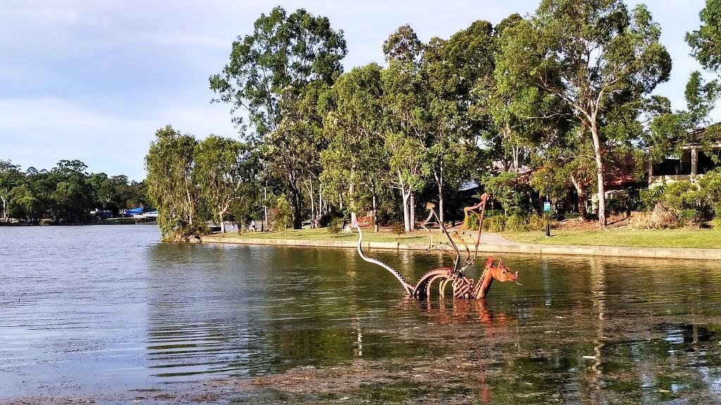


Presidents Message¸ October 2026

As I start my term as President of NSA Forest Lake Branch, I would like to thank Brian for all the effort he has put in over the last 3 years. I would also like to thank the Team who put up their hands to keep this wonderful club functioning. Without their efforts we would not be enjoying the connection this Club offers.

A survey that was done in 2025 is very encouraging in that it said 55% of the aged population rarely felt lonely and about 76% had no barriers to getting out and about. However we must not forget that this still leaves many in our age group who do feel isolated and lonely, so I encourage all members to do their part by simply saying "Hello" and take time to speak to each other.

As we get closer to the end of the year and start to think about gifts for Christmas, it is a good time to be aware of a scam that is occurring with gift cards bought in the supermarkets. It has been reported that the criminals remove gift cards from supermarket displays and carefully open the package, record the number and redemption codes. The card is then returned to the packaging and replaced on the supermarket shelves. Once an unsuspecting shopper buys the card it becomes active. The criminal networks monitor the recorded details and when it is active they quickly spend the balance. If you are going to purchase a gift card, check the packaging before purchase for any tampering.

Finally I must report on a wonderful day that was had by all on our outing to Landsborough.A visit to the museum was very interesting followed by a wonderful lunch some at the hotel, some at the fish shop and some at the bakery. By the talking I heard half way up the carriage from where we sat the day was a great success all for $1 return.
John Young
President


Dan Baldwin Peter Dunell

Lynne Ball Jenny Hasham-Jones

Linley Bates Carmel Japuncic

Vera Bentley Rhonda Martens

Paula Cockle Marjorie Stephenson

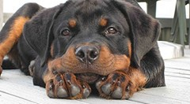


Our next meeting is on 8TH October 2026
and this will be at
DOGS QUEENSLAND
247 King Avenue, DURACK.

ACTIVITY REPORT
GENERAL MEETING 8th OCTOBER 2026
SEPTEMBER: Thursday 24th Our train trip to Landsborough was a great success – such a lovely village, with heaps to offer, and the weather was wonderful too. More train trips to come.
OCTOBER: Wednesday 7th FREE OVER 50’s Expo at Riverlife Baptist Church at Seventeen Mile Rocks and will have a stand starting at 8.30am. MUST RSVP FOR CATERING PURPOSES.
Thursday 8th General meeting with Peter Dunnell sharing the “History of the Men’s Shed” with us.
Thursday 27th “Esk Bush Bashers” – $70 pp with morning tea at Wivenhoe Dam and sandwich/cake/tea/coffee for lunch at venue – included in price. (Nothing extra now for Gluten Free). Payment prior to October meeting, please.
AS THE “BUSH BASHERS” DON’T CHARGE THEIR TIME – THERE WILL BE A DONATION BOX AS THEY SUPPORT CHARITIES (PLEASE BRING CASH TO HELP, IF YOU WISH).
BUS will leave from Aldi car park at Forest Lake Shopping Centre at 8.00 am and will leave Esk around 2.00pm – returning to Forest Lake by 3.10pm.
NOVEMBER: Thursday 12th General meeting with our speaker for Remembrance Day being Lt Col George Hulse.
Thursday 26th Lunch at Durack Tavern – own expense
GRAB CHRISTMAS GIFTS
We have all seen Cheryl W madly crocheting on our coach trips. Now some of her items will be displayed and available for purchase on a table at the rear of the room at the October meeting. Items can only be purchased (cash only) prior to the meeting and at the close of the meeting.
Orders can also be taken.
DECEMBER: Thursday 3rd Christmas Lunch party – 11.30am arrival for lunch at 12.00 pm. Finishes at 2.00 pm. usic: David Barry, lucky door gift cards, hampers donated by Hon Milton Dick MP, gift card $50 from Margie Nightingale, Cr Charles Strunk, and Heritage Bank - $55.00 Always a fun day.
Lynne B + Activity Team

Branch email - nsaforestlakepres@gmail.com
President – John - 0410480758 Vice President – Peter - 0404829518 Secretary - Janelle - 0402097564 Treasurer - Colin - 0426 863 506
Membership – Norah - 0421282052 Activities - Lynne B. - 0412 122 161 Publicity - Lorraine . – 0409275016 Welfare – Lynne F. - 0408889479


A special thank you goes to our VOLUNTEERS without whom our
meetings would not run so smoothly.
The Committee would like to thank all supporters of the NSA Forest Lake Branch for photocopying, financial reports and other support material.
Thank you for the printing of our monthly newsletter to MARGIE NIGHTINGALE and her team at her Office. Margie is our local state member.

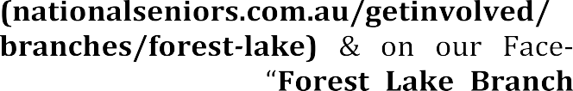


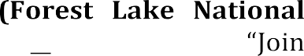


Hi Members: Could you please try to
have small change with you to pay when entering our meetings. This is to pay for morning tea and as our lovely
Volunteers manning the desk do not
have access to a lot of change and big notes make it very difficult for them.
Also members , could you please let a committee member know when paying by cash through a bank branch

We strongly encourage Members to pay for excursions via Internet banking or by depositing payment over the counter at Heritage Bank Forest Lake.
Do you know of any Members who are un-well, had a bereavement in the family or feel-ing down? Often, we are not aware so if you know of any Members, please let our Welfare Officer know. Lynne has kindly taken on this important role for our club for the next month.
Phone 0408889479 or email on lf0gg61@gmail.com
- Trips Payment
Bank Transfer & Direct Deposit
Account Name: National Seniors Australia Forest
Lake Branch Inc
Bank account details: BSB-638 070
Acc No-12471674
Please include your name & event name on the transfer and receipt for identification.
Example – Smithx1Xmas party Surname (Smith)
Number going (1)
Event (Branch Christmas Party)
EFTPOS
The Branch has a "Square card" hand-held EFT-POS machine to take payments. Members wishing to pay by card using this method can do so at Branch Meetings. Receipts will be emailed. Please note payment via this method will incur a sur-charge of 1.9%.
Cash or Cheques
To assist the trips desk please write on an envelope:
Joe Smith
Branch Christmas Party
$ ?
Gluten Free
Your name Trip details
Payment amount
Dietary requirements
Seal your payment inside the envelope and hand it to the trips desk.
Unless it is in anEnvelope as stated above the trips table will not accept any pament.
Full Payment will be due at the monthly meeting prior to the trip.
Branch Refund Policy
Cancellation of an outing Travel Insurance for our away trips is strongly recommended.
The branch policy for late cancellations. Notify the Secretary or Treasurer 48 hours beforehand. A Medical Certificate will be required to receive a refund if notification is 24 hours or less. In the case of a sudden medical emergency on the day which cannot be prevented, the Management Committee will consider the matter with respect to a refund.

When we have to book seats on a bus or give numbers for a booked away trip or luncheon and are still required to pay even in the case of a cancellation by a member, a refund will not be provided.
In the event of an activity/outing being cancelled due to some unforeseen circumstance beyond our control, eg: storm, transport breakdown, etc, and cannot be rescheduled, members will be refunded

NATIONAL SENIORS AUSTRALIA FOREST LAKE BRANCH
CALENDAR - OCTOBER TO DECEMBER

OCTOBER

Monday 5th Public Holiday – Kings Birthday

Wednesday 7th FREE Over 50’s – Riverlife Church, Seventeen FREE Mile Rocks. Many stalls, speakers, FREE morning tea/lunch. FINAL EXPO.

Thursday 8th General Meeting held at Dogs Queensland $8.00
9.30am – Speaker Peter Dunell on “History of the Men’s Shed” (Speaker from Australian Unity – Changes to our Care) now changed to April 2027.

Tuesday 27th Esk Bush Bashers Event at Esk – A group of $70.00 talented fun loving musicians and singers who have performed for over 24 years and love to involve their guests. GREAT DAY.
Payment prior to October meeting, please.

NOVEMBER

Thursday 12th General Meeting held at Dogs Queensland $8.00
9.30am – Speaker Lt. Col. George Hulse –
Remembrance Day.

Thursday 26th Lunch --- Durack Tavern. Own Expense

DECEMBER

Thursday 3rd Christmas Lunch party – Blue Fin Fishing Club $55.00 Sumptuous 2 course meal, free lucky door tickets
for many raffle prizes, including gift vouchers, music and dancing

2026 People First Community Lottery

Last chance for Peoples Lottery. Ticket Sales close on the 8th October.
To buy head to communitylottery.com.au
Type in Forest Lake National Seniors
Tickets are $2.00 each and pay through the website using a Debit Card

Just a few photos from our Landsborough day out.

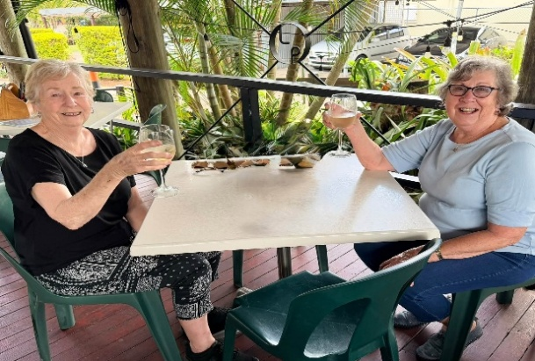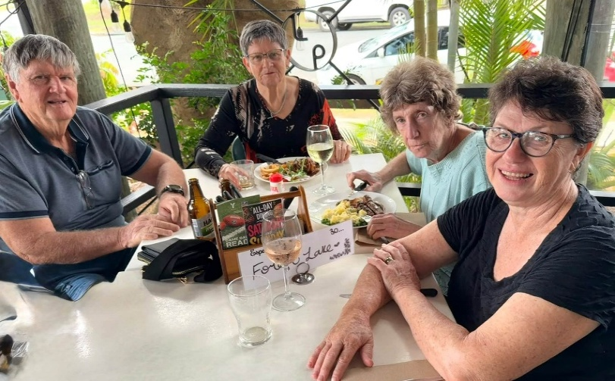
Nice lunch area at rear of the hotel

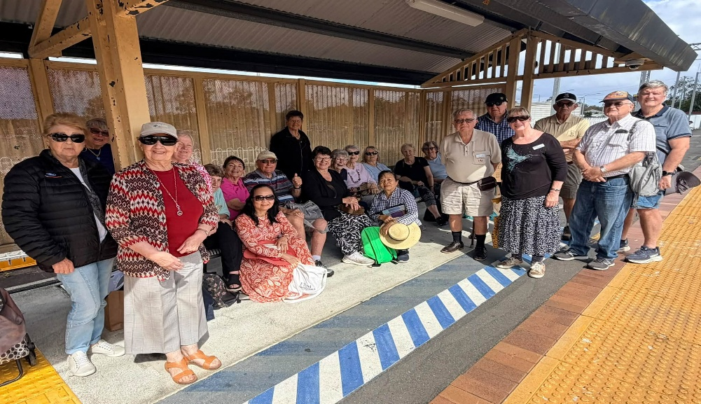
Waiting patiently for our train back to Forest Lake.


LAUGHTER IS THE BEST MEDICINE

